Work Integrated Learning Programmes
M.Tech Software Engineering



Scalable Services
Assignment 1
Microservices Design and Development Report
Movie Ticket Booking System

By: Group 9
Name | BITS ID
Gujar Neel Lukesh | 2025tm93111
Yamuna P Hegade | 2025tm93019
Bhandari Akshay Sunil | 2025tm93112
Naveen Venkat P | 2025tm93528

1. Problem and Scope

1.1 Objective
The objective of this assignment is to design and implement a scalable Movie Ticket Booking System using a microservices architecture. The system demonstrates key distributed systems concepts such as service decomposition, database-per-service design, concurrency control, idempotent request handling, and Saga-based transaction management.
The implemented application consists of five independent microservices:
- User Service
- Show Service
- Booking Service
- Payment Service
- Notification Service
The system supports end-to-end movie ticket booking workflows while ensuring consistency, fault tolerance, and scalability.

1.2 Problem Statement
The system allows users to book movie tickets while handling real-world distributed systems challenges.
Contended Resource
- Seats
Cross-Service Transaction
- Book Seat
→ Reserve Seat
→ Payment
→ Confirmation
→ Notification
Unsafe Operation
- Payment Processing
Mock Failing Dependency
- Payment Gateway
Challenges Implemented
- Challenge 1: Concurrency
- Challenge 2: Idempotency
- Challenge 3C: Saga Compensation

1.3 Assumptions
- All services run locally and communicate using REST APIs.
- SQLite databases are used for persistence.
- Payment Gateway is simulated.
- Notification delivery is mocked and stored for verification.
- Services communicate synchronously over HTTP.

1.4 Business Rules
- BR1: A seat can only be reserved once.
- BR2: A seat must be AVAILABLE before reservation.
- BR3: Only ACTIVE users are allowed to create bookings.
- BR4: Booking can be CONFIRMED only after successful payment.
- BR5: Duplicate payment requests with the same idempotency key are processed exactly once.
- BR6: Payment failure triggers booking cancellation and seat release.

1.5 Out of Scope
- Real payment gateway integration
- Email/SMS provider integration
- Authentication and authorization
- Distributed deployment
- Kubernetes orchestration
- Production-grade monitoring

2. Service Decomposition
Responsibility Table
Service | Responsibility
User Service | User registration and lifecycle management
Show Service | Show and seat management
Booking Service | Booking lifecycle and Saga orchestration
Payment Service | Payment processing and idempotency
Notification Service | User notifications

Each service owns a single business capability and database. This separation reduces coupling, improves maintainability, and allows independent deployment and scaling.

Alternatives Considered
Alternative 1 – Monolith
Rejected because:
A monolithic system would not demonstrate distributed-systems concepts and would limit scalability.
Alternative 2 – Booking + Payment Combined
Rejected because:
Payment processing requires separate idempotency logic and business rules.

3. System Architecture
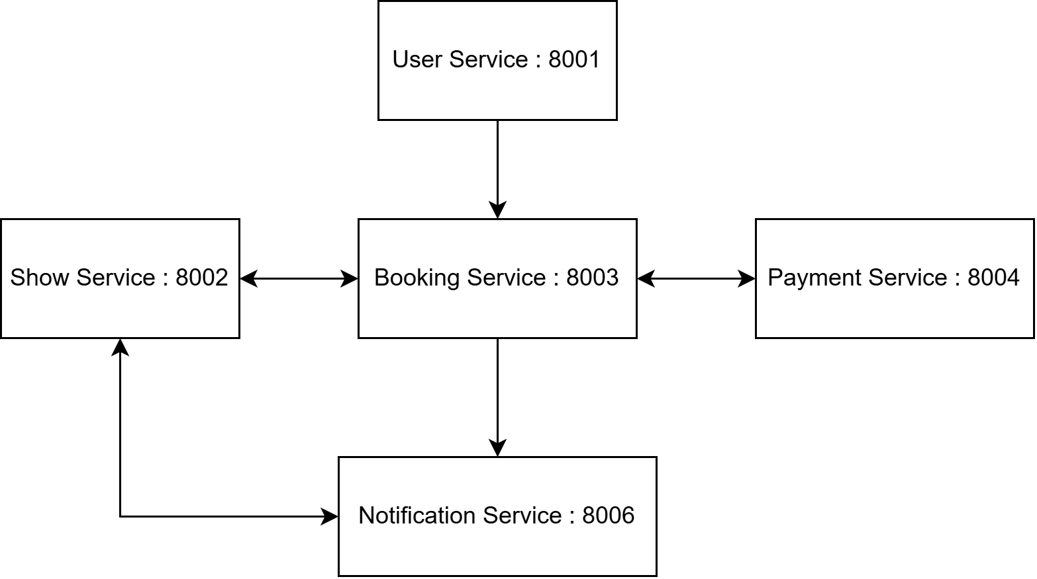
Figure 1. Microservices Architecture of the Movie Ticket Booking System
Data Ownership
Service | Database Ownership
User Service | Users
Show Service | Shows, Seats
Booking Service | Bookings
Payment Service | Payments
Notification Service | Notifications
Cross-Service References
Services do not share databases. References such as user_id and show_id are stored locally while validation occurs through API communication.
Description
The system follows the microservices pattern where each business capability is implemented as an independent service.
Service | Responsibility
User Service | Manages users and account status
Show Service | Manages shows and seat inventory
Booking Service | Handles bookings and Saga orchestration
Payment Service | Processes payments and idempotency
Notification Service | Sends booking notifications
Service Ports
Service | Port
User Service | 8001
Show Service | 8002
Booking Service | 8003
Payment Service | 8004
Notification Service | 8006

Sequence Diagrams
Successful Booking Flow
User
|
Create Booking
v
Booking Service
|
Reserve Seat
v
Show Service
|
Success
v
Booking Service
|
Process Payment
v
Payment Service
|
Success
v
Booking Service
|
Confirm Booking
|
Send Notification
v
Notification Service
|
v
Booking Confirmed

Steps:
- User creates booking.
- Booking Service reserves seat.
- Payment Service processes payment.
- Booking is confirmed.
- Notification is generated.

Failed Booking Flow
User
|
Create Booking
v
Booking Service
|
Reserve Seat
v
Show Service
|
Success
v
Booking Service
|
Process Payment
v
Payment Service
|
Failure
v
Booking Service
|
Release Seat
v
Show Service
|
Seat Released
v
Booking Service
|
Cancel Booking
|
Send Notification
v
Notification Service
|
v
Booking Cancelled

4. Data Design
USER SERVICE
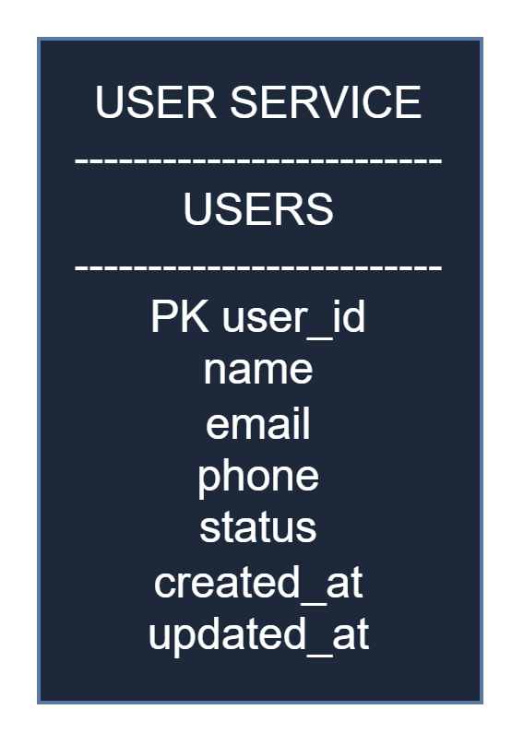

SHOW SERVICE
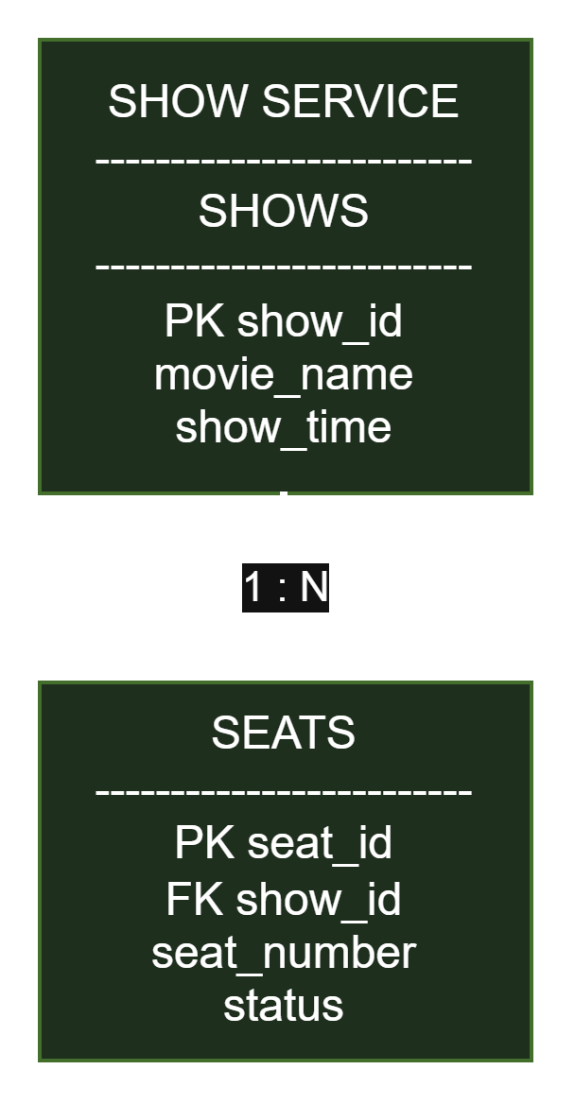

BOOKING SERVICE
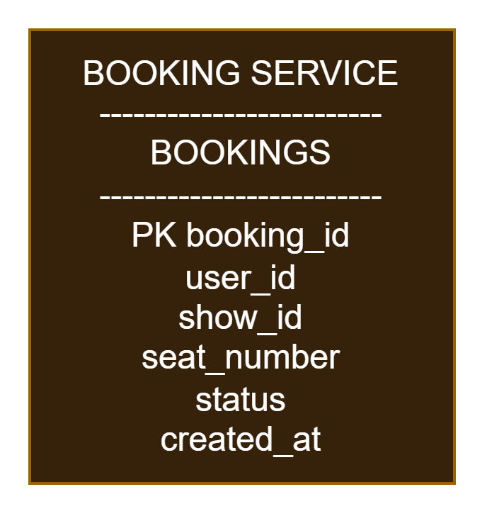
PAYMENT SERVICE
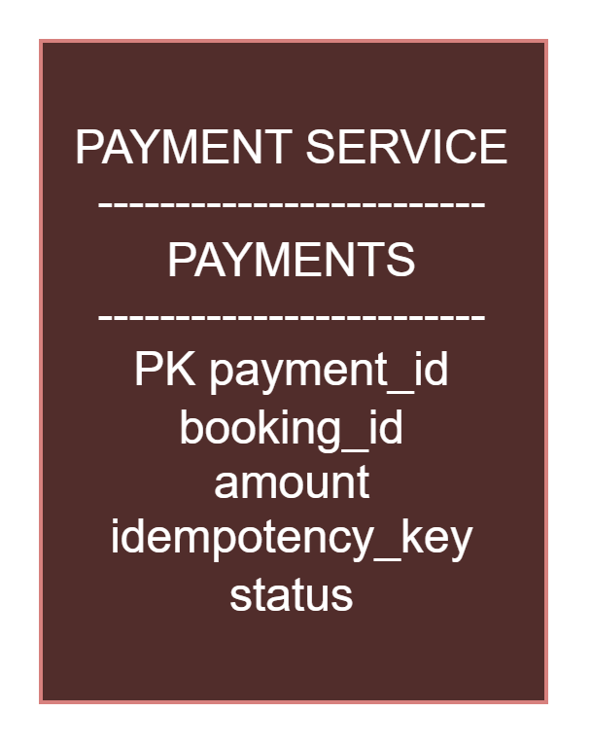

NOTIFICATION SERVICE
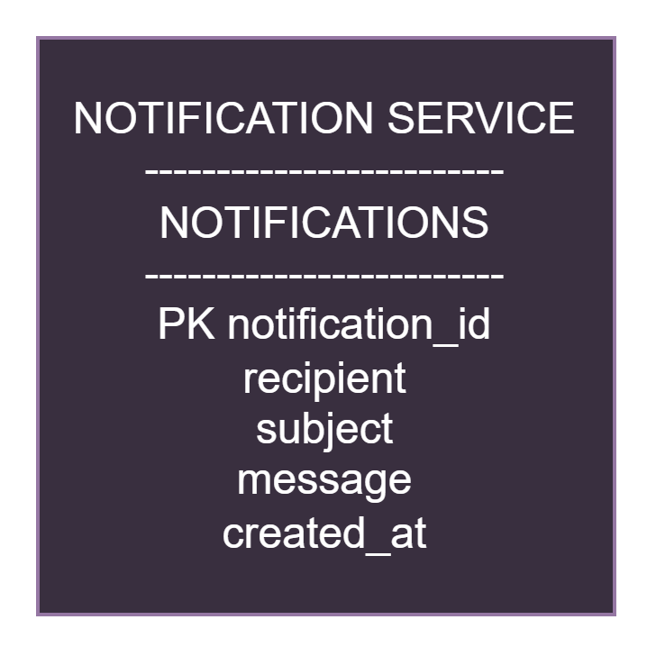
Database-per-Service Pattern
The solution follows the Database-per-Service architectural pattern. Each microservice owns and manages its own database and no service directly accesses another service's data store. Communication between services is performed exclusively through REST APIs. This approach reduces coupling, preserves service autonomy, and improves maintainability.
Data Ownership Table
Service | Data Owned
User Service | Users
Show Service | Shows, Seats
Booking Service | Bookings
Payment Service | Payments
Notification Service | Notifications
Cross-Service References
The system maintains logical relationships between services using identifiers rather than direct database joins.
Reference | Purpose
user_id | Links bookings to users
show_id | Links bookings to shows
booking_id | Links payments and notifications to bookings
All validation and data retrieval involving these references are performed through service APIs rather than database access.

Status Models
Show Service Seat States
- AVAILABLE
- RESERVED
- BOOKED
Booking Service States
- PENDING
- RESERVED
- CONFIRMED
- PAYMENT_FAILED
- CANCELLED
These states are used to enforce business rules, support concurrency control, and implement the Saga workflow.

Seed Data Used During Integration Testing
The integration environment was initialized using the following sample dataset:
Show
- Show ID: 1
- Movie: Demo Movie
- Time: 18:00
Seats
- A1
- A2
- A3
- A4
- A5
All seats were initially configured with status:
AVAILABLE
This dataset was used for concurrency testing, Saga validation, and end-to-end integration verification.

5. API Design
Endpoint Summary
Service | Method | Endpoint
User | POST | /api/v1/users
User | GET | /api/v1/users/{id}
Show | GET | /shows
Show | POST | /seats/reserve
Show | POST | /seats/release
Booking | POST | /bookings
Booking | GET | /bookings/{id}
Booking | POST | /bookings/{id}/process
Payment | POST | /payments
Notification | POST | /notifications
Error Model
HTTP Code | Meaning
400 | Business Rule Violation
404 | Resource Not Found
409 | Concurrency Conflict
422 | Validation Error
500 | Internal Error
Example:
{
"detail": "Seat is not available for reservation"
}

5.1 User Service
Responsibilities:
- Register users
- Retrieve user information
- Activate/deactivate users
- Enforce account lifecycle constraints
APIs
- POST /api/v1/users
- GET /api/v1/users/{id}
- POST /api/v1/users/{id}/activate
- POST /api/v1/users/{id}/deactivate

Screenshots
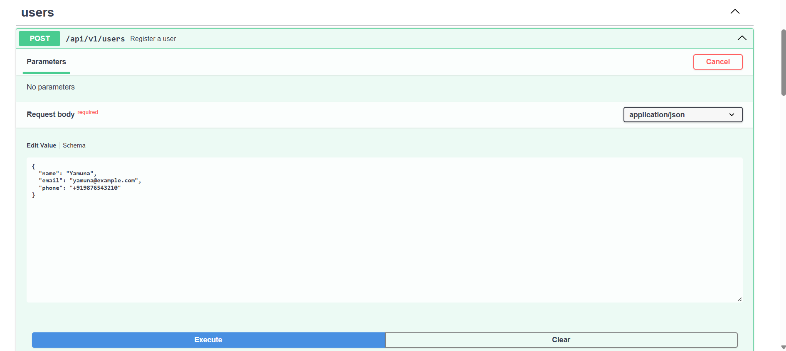
Figure 2. User Creation API
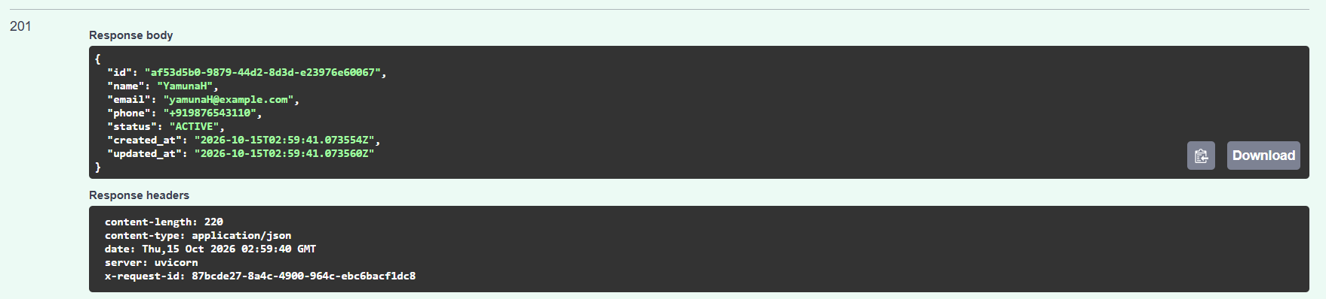
Figure 3. Successful User Retrieval
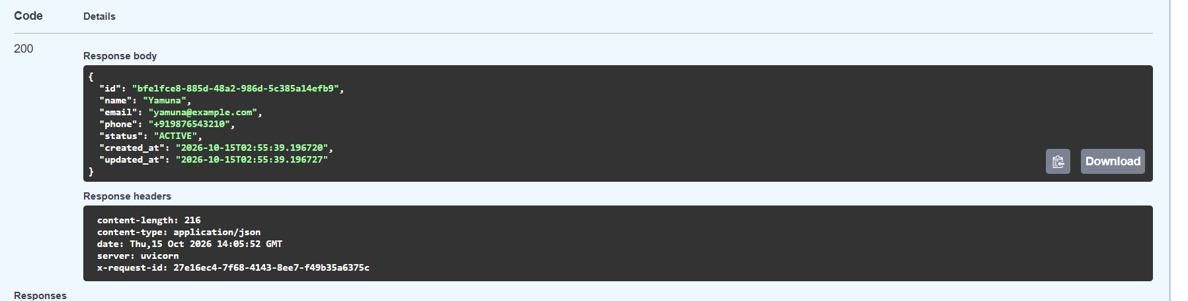
Figure 4. User Service Validation

5.2 Show Service
Responsibilities:
- Manage movie shows
- Manage seat inventory
- Reserve seats
- Release seats
APIs
- GET /shows
- POST /seats/reserve
- POST /seats/release

5.3 Booking Service
Responsibilities:
- Create bookings
- Maintain booking states
- Coordinate Saga workflow
APIs
- POST /bookings
- GET /bookings/{booking_id}
- PUT /bookings/{booking_id}/status
- POST /bookings/{booking_id}/process
- POST /reserve-seat
Booking State Machine
Success Flow:
PENDING
↓
RESERVED
↓
CONFIRMED
Failure Flow:
PENDING
↓
RESERVED
↓
PAYMENT_FAILED
↓
CANCELLED

5.4 Payment Service
Responsibilities:
- Process payments
- Enforce idempotency
- Support Saga compensation
API
- POST /payments

5.5 Notification Service
Responsibilities:
- Create notifications
- Retrieve notification history

OpenAPI Links
Swagger/OpenAPI Endpoints
User Service:
http://localhost:8001/docs
Show Service:
http://localhost:8002/docs
Booking Service:
http://localhost:8003/docs
Payment Service:
http://localhost:8004/docs
Notification Service:
http://localhost:8006/docs
All services expose automatically generated OpenAPI specifications through FastAPI Swagger interfaces, enabling interactive testing and API discovery.

Sample Request / Response

Sample Booking Request
{
"user_id": "b4f6bbc7-ef74-41b8-86c1-c1fc787536e1",
"show_id": 1,
"seat_number": "A2"
}
Sample Booking Response
{
"booking_id": 7,
"status": "PENDING"
}

Sample Payment Request
{
"idempotency_key": "PAY123"
}
Sample Payment Response

{

"message": "Payment processed"

}

6. Engineering Challenges

Challenge 1 – Concurrency Control
Objective
Prevent multiple users from reserving the same seat simultaneously.
Problem
Multiple users may attempt to reserve the same seat at the same time, potentially causing double booking and inconsistent seat allocation.
Implementation
The Show Service performs atomic seat reservation by updating seats only when their current state is AVAILABLE.
Design Choice
Seat reservation is implemented using a single atomic database update operation that succeeds only when the seat status is AVAILABLE.
Alternative Considered
A distributed lock mechanism was considered. However, it was rejected because it would introduce additional complexity for an assignment-scale implementation.
Test Scenario
Twenty concurrent reservation attempts were executed against the same seat.
Screenshot
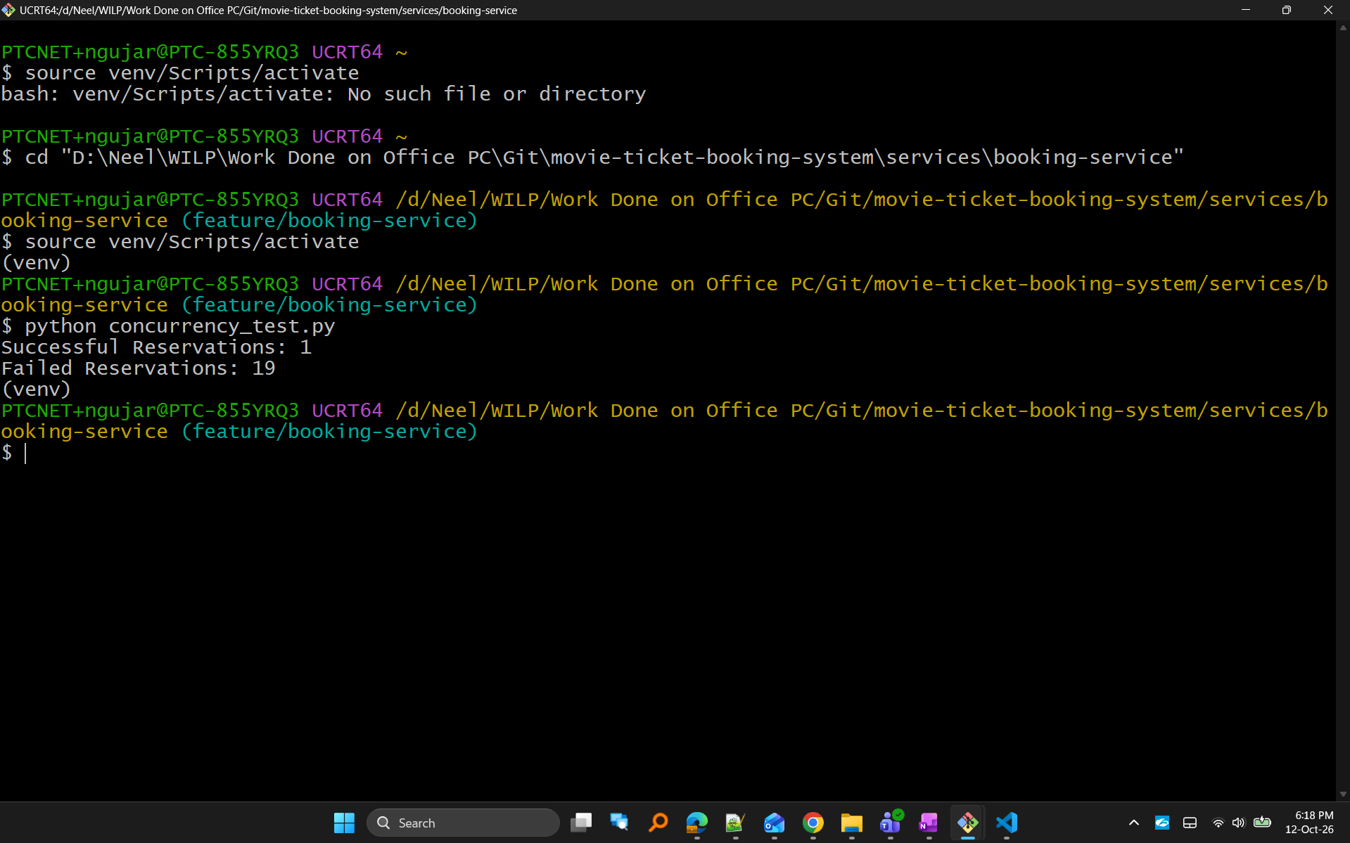
Figure 5. Concurrency Test Results
Results
Successful Reservations: 1
Failed Reservations: 19
Analysis
Only one request successfully reserved the seat while all remaining requests were rejected, demonstrating correct handling of a contended resource.
Limitation
The implementation uses SQLite and local execution for demonstration purposes. In a production environment, stronger concurrency mechanisms and distributed deployment strategies may be required.

Challenge 2 – Idempotency
Objective
Prevent duplicate payment processing.
Problem
Network retries or client resubmissions can result in the same payment request being sent multiple times.
Implementation
The Payment Service stores and validates idempotency keys.
Repeated requests using the same key return a duplicate response instead of creating a new payment record.
Design Choice
Each payment request contains a unique idempotency key which is stored and checked before processing.
Alternative Considered
Transaction fingerprinting based on payment payloads was considered but rejected because explicit idempotency keys provide a simpler and more reliable solution.

Screenshots
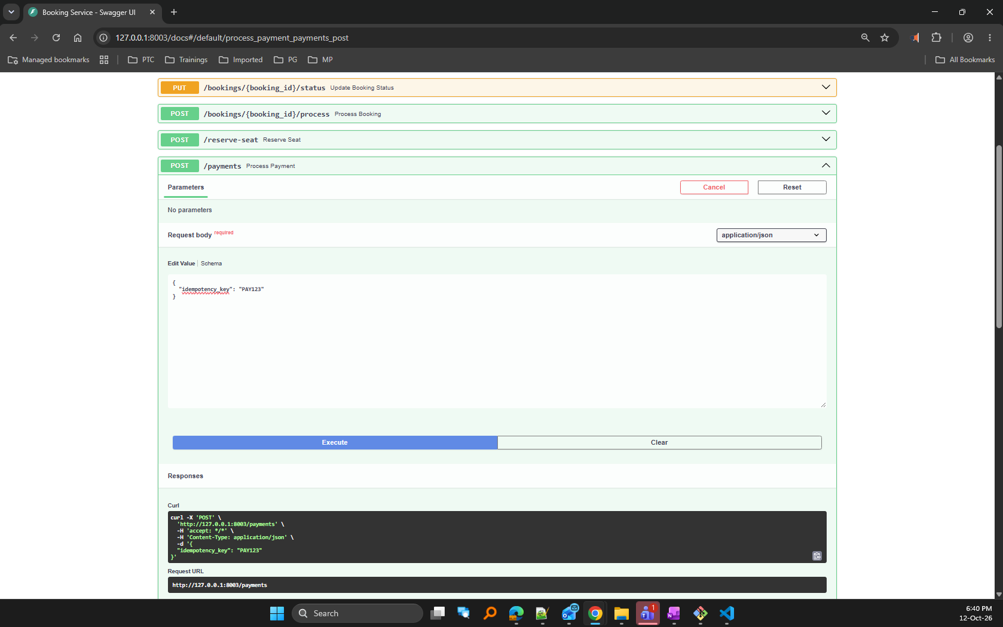
Figure 6. Initial Payment Processing
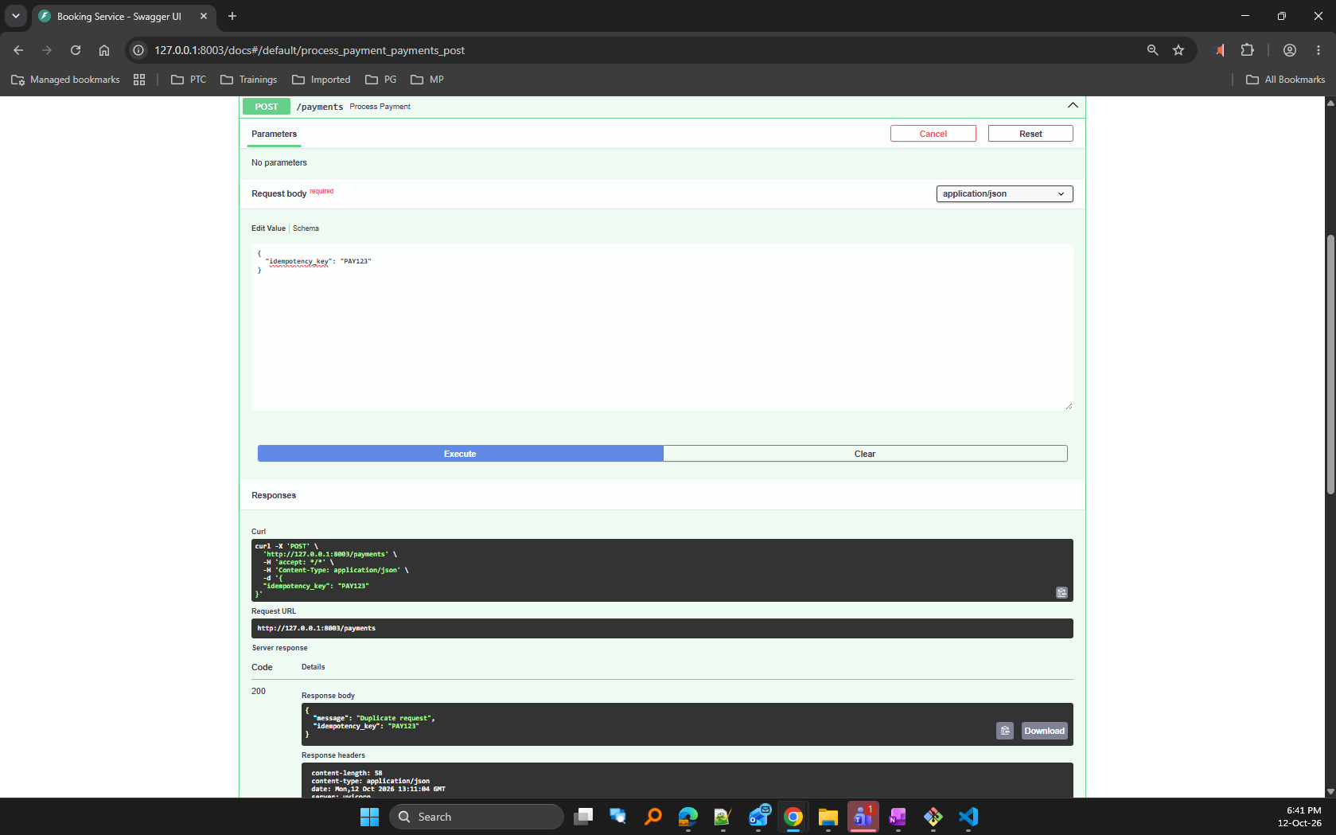
Figure 7. Duplicate Request Detection
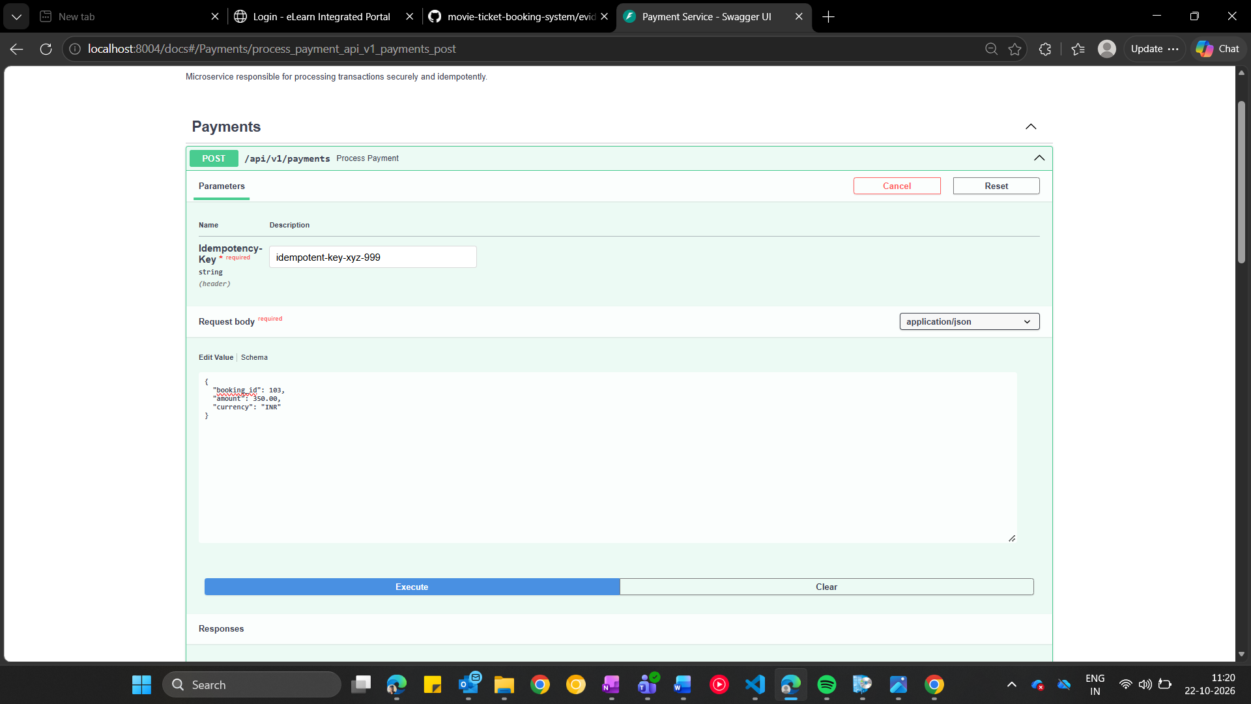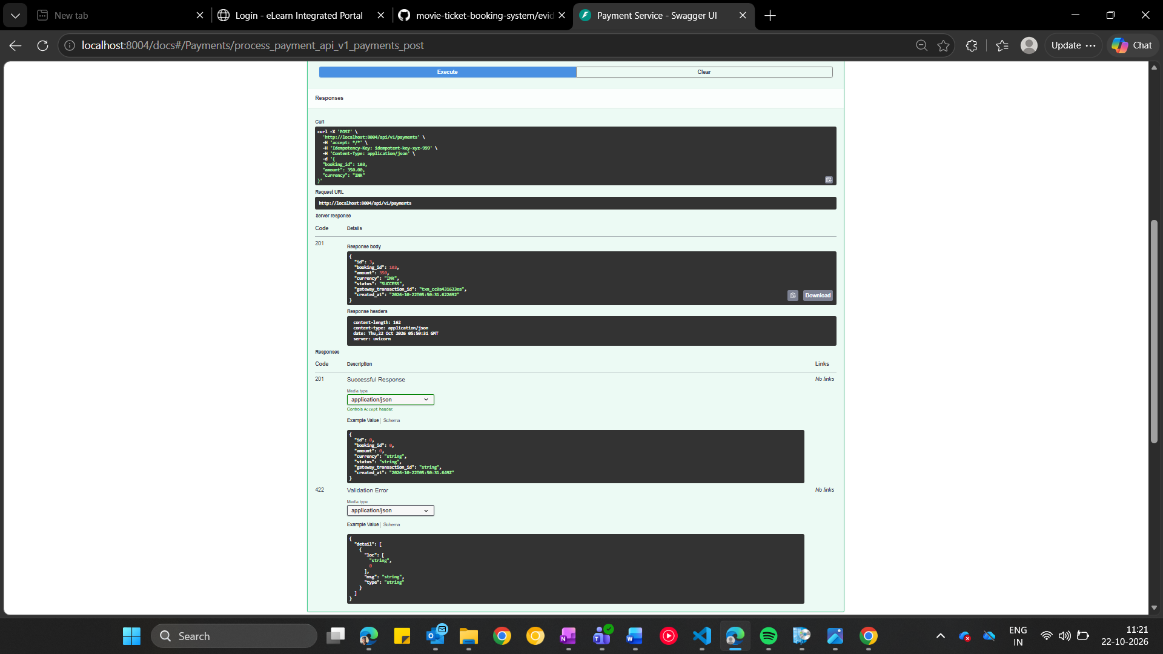
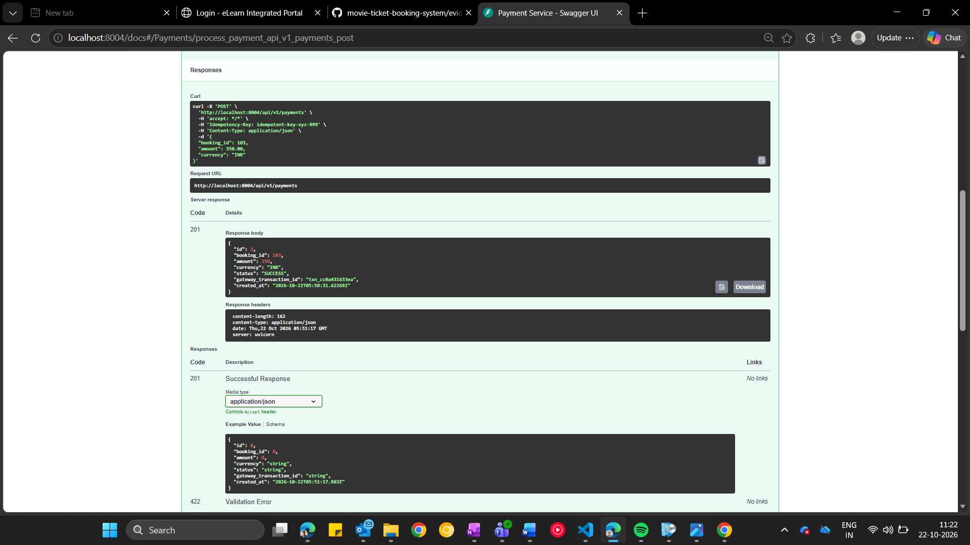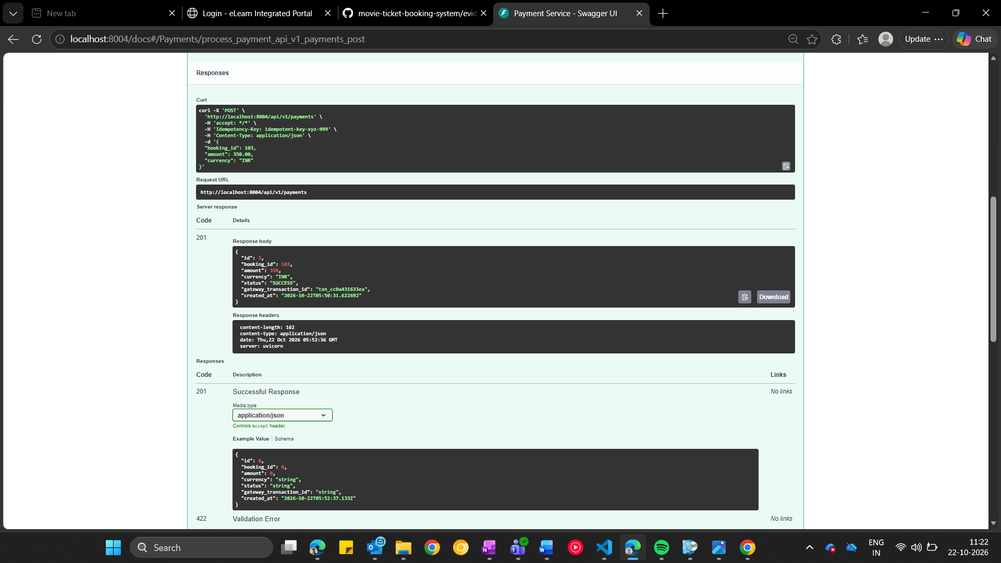
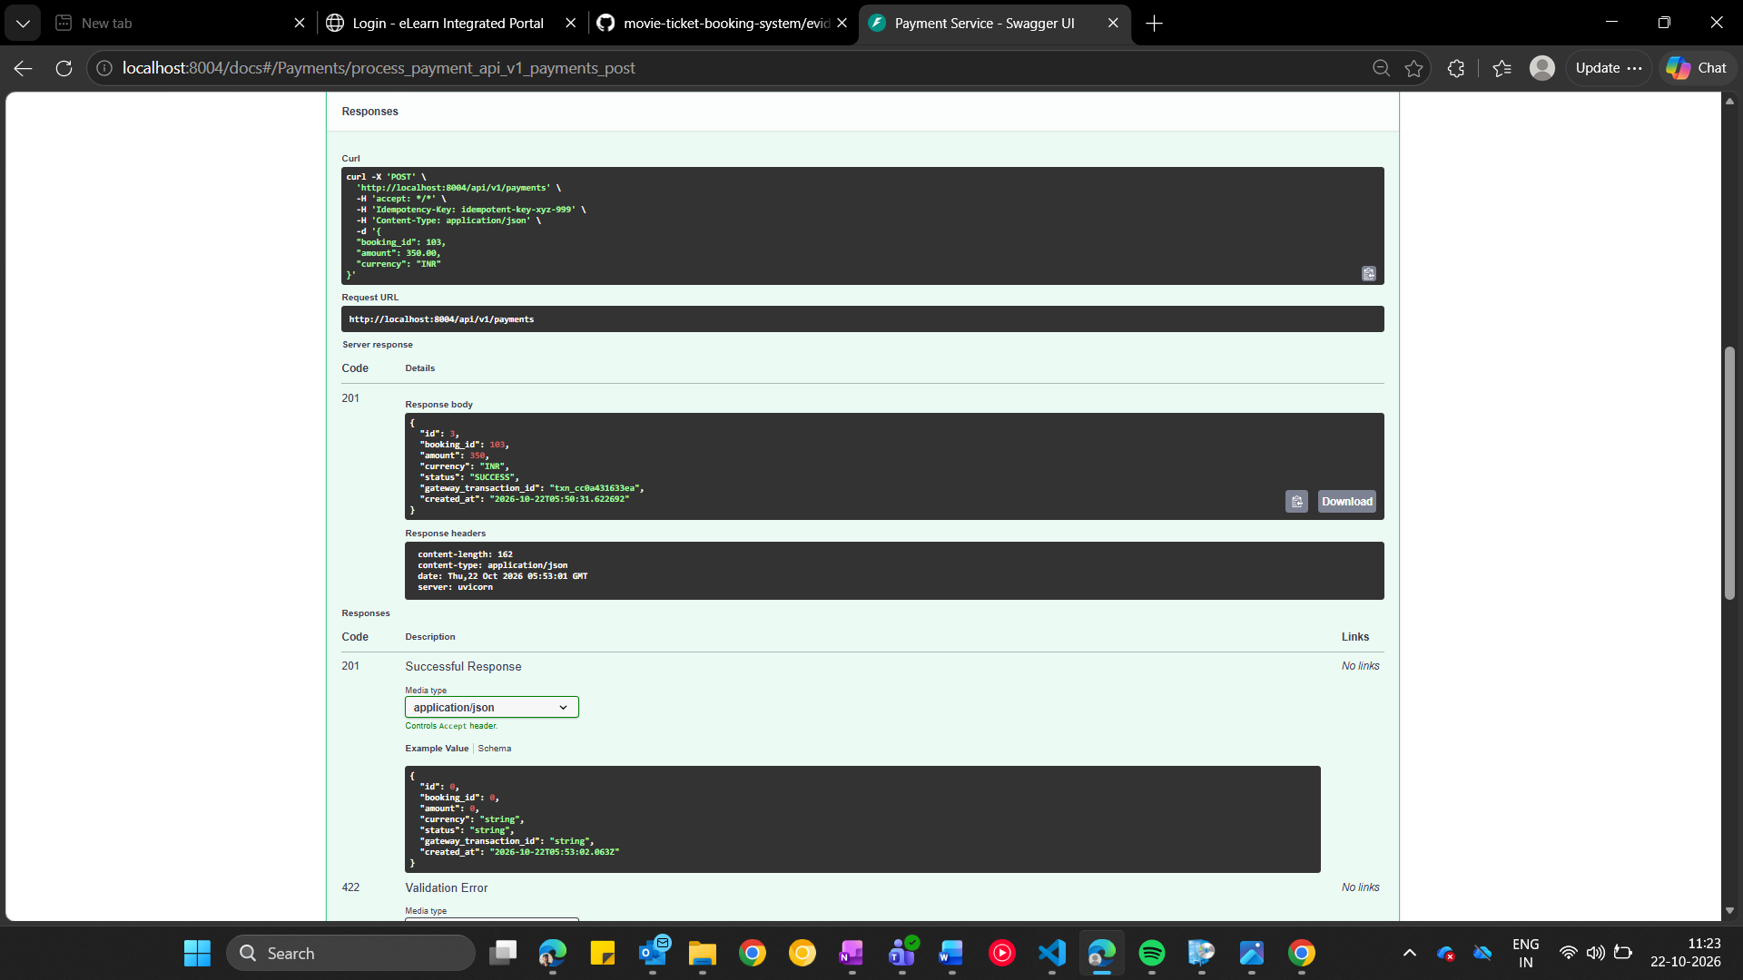
Figure 8. Payment Service Idempotency Validation
Test Result
- PAY123 → Processed
- PAY123 → Duplicate
- PAY123 → Duplicate
Conclusion
Only a single payment record is created even when identical requests are repeatedly submitted.
Limitation
The implementation assumes trusted idempotency key generation by the client. Production systems may require additional key expiration and lifecycle management.

Challenge 3C – Saga Pattern
Objective
Implement distributed transaction handling across services.
Problem
A seat may already be reserved when a payment subsequently fails, causing data inconsistency across services.
Design Choice
The Booking Service acts as a Saga Orchestrator and coordinates the distributed workflow.
Alternative Considered
Saga choreography was considered but rejected because orchestration provides simpler control flow and easier debugging for educational and demonstration purposes.

Successful Booking Saga
Screenshots
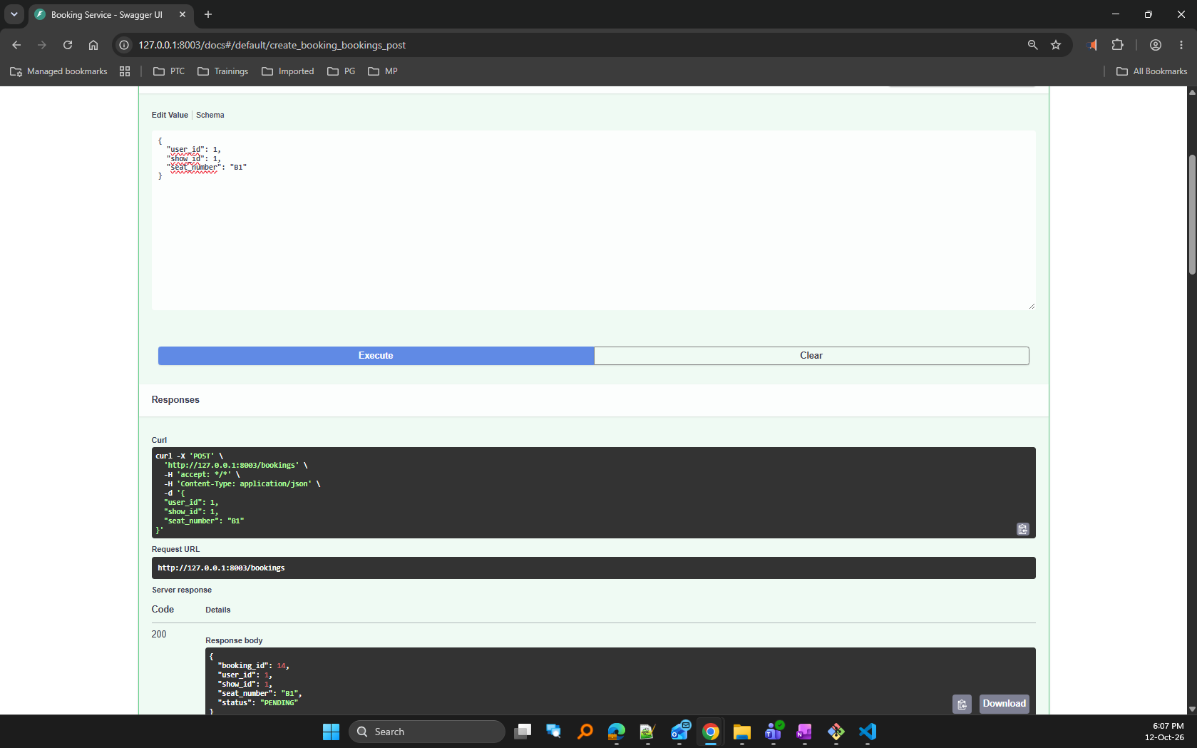
Figure 9. Successful Booking Saga
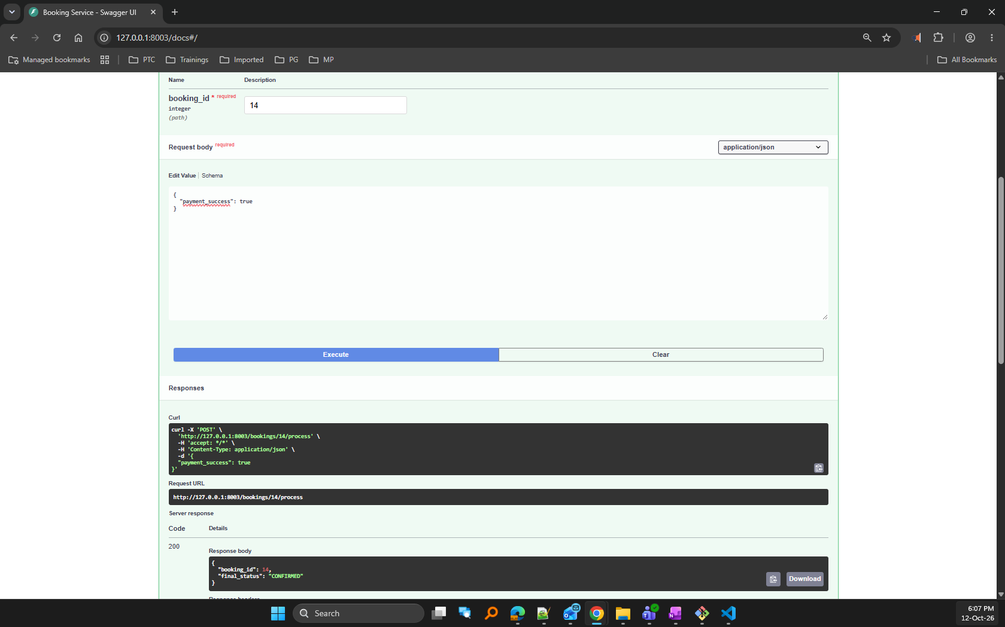
Figure 10. Confirmed Booking State
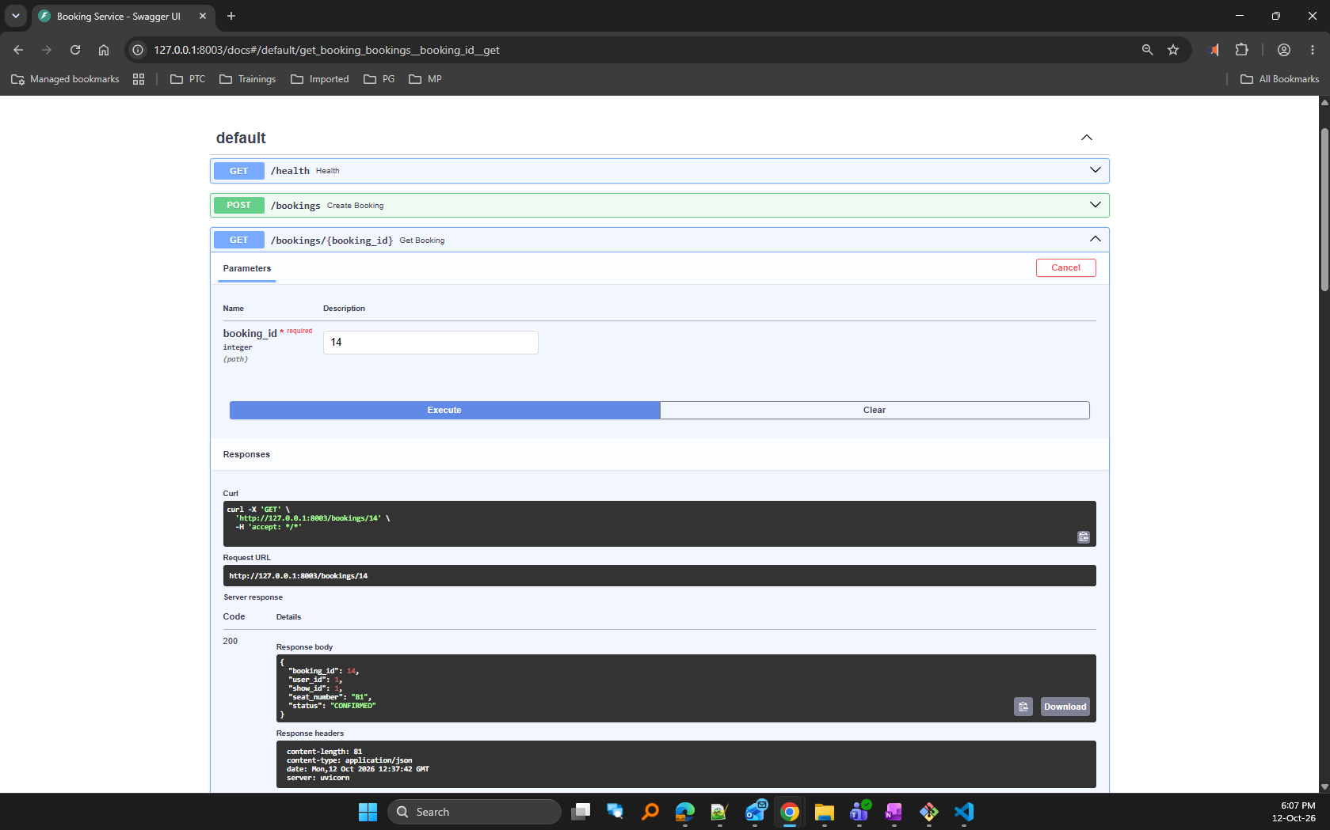
Figure 11. Confirmed Booking State
Flow
PENDING
↓
RESERVED
↓
CONFIRMED
Notification:
- Booking confirmed

Compensation Workflow
Screenshots
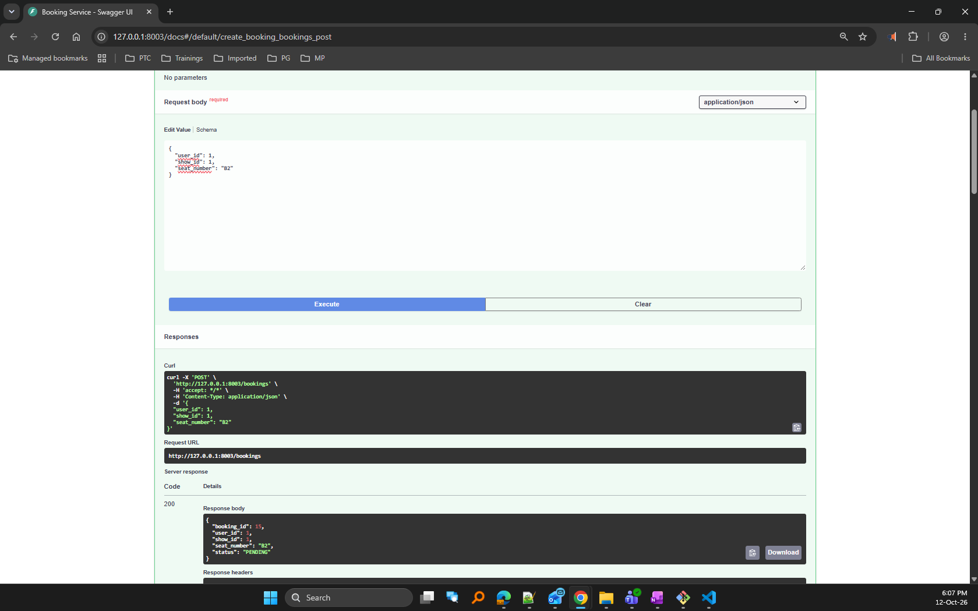
Figure 12. Payment Failure Compensation
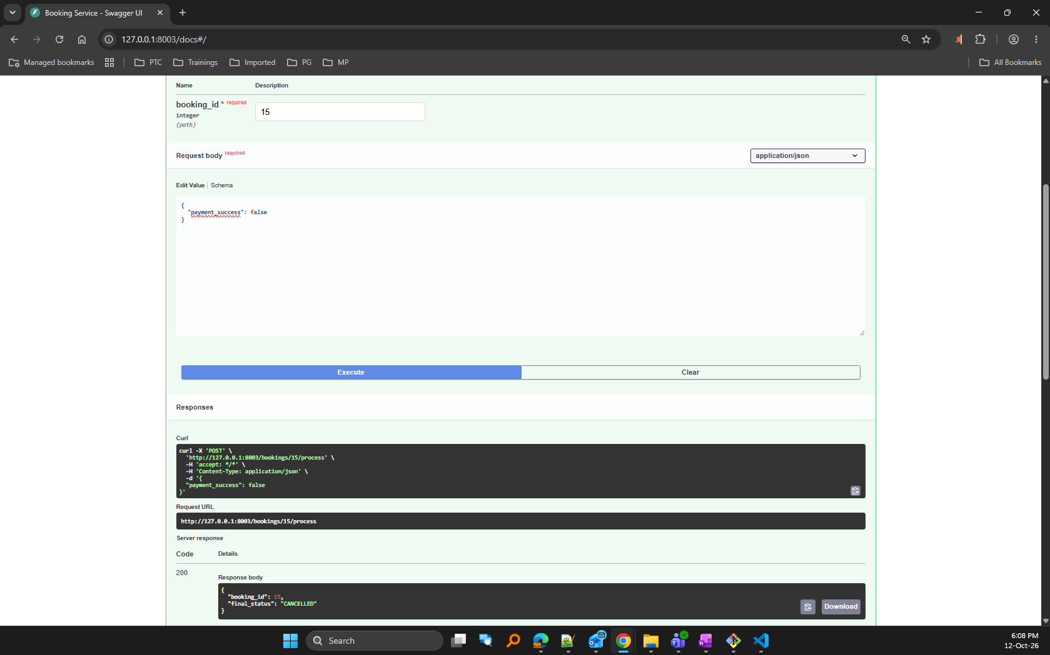
Figure 13. Cancelled Booking State
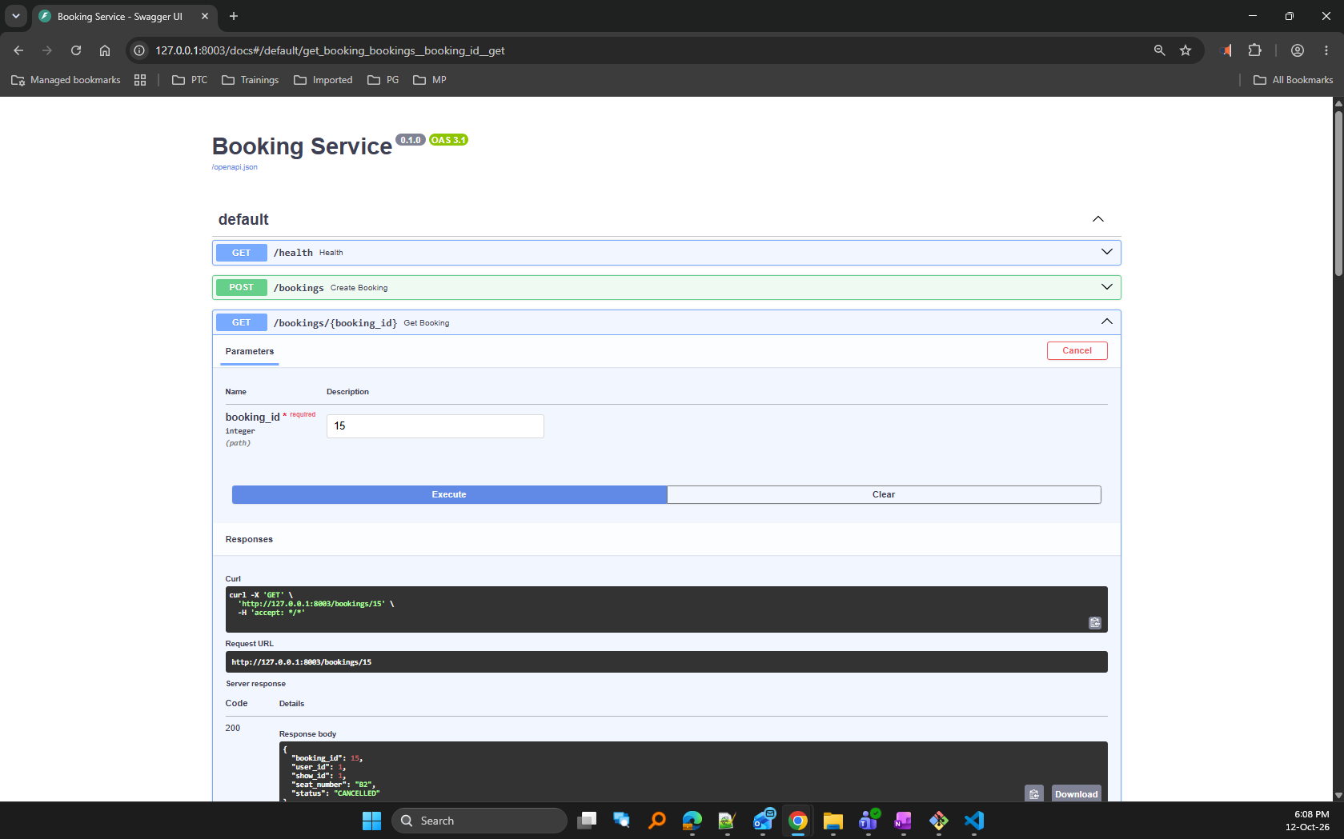
Figure 14. Cancelled Booking State
Flow
PENDING
↓
RESERVED
↓
PAYMENT_FAILED
↓
CANCELLED
Compensation:
- Seat released
- Booking cancelled
Notification:
- Booking cancelled because payment failed
Evidence
End-to-end integration testing verified that successful payments lead to confirmed bookings while failed payments trigger compensation actions and seat release.
Limitation
The payment gateway is simulated. Production implementations would require integration with a real payment provider and stronger failure recovery mechanisms.

7. Testing
Testing Strategy
The system was validated using:
  - Swagger UI testing
  - Postman-based API testing
  - Automated pytest unit tests
  - Concurrency testing scripts
  - Idempotency testing
  - End-to-end integration testing through integration_demo.py
User Service
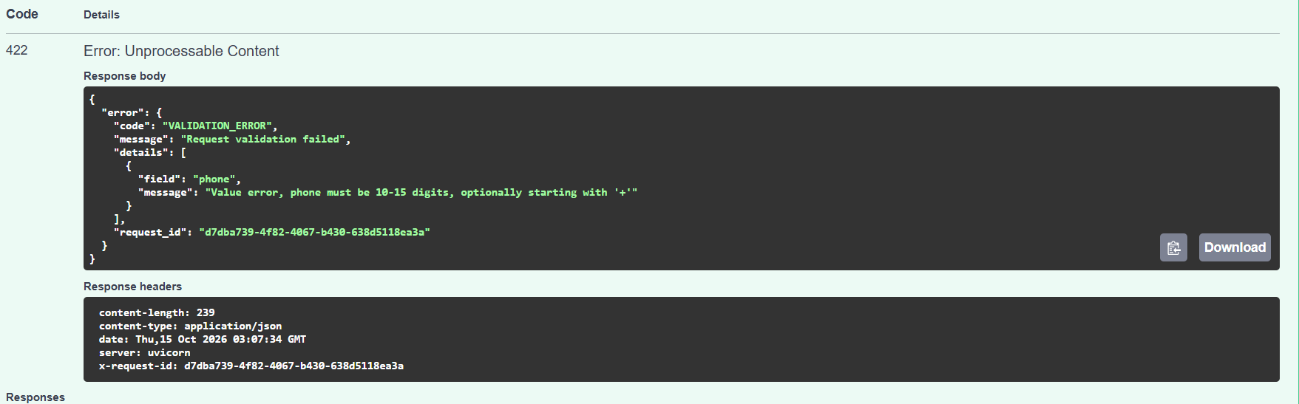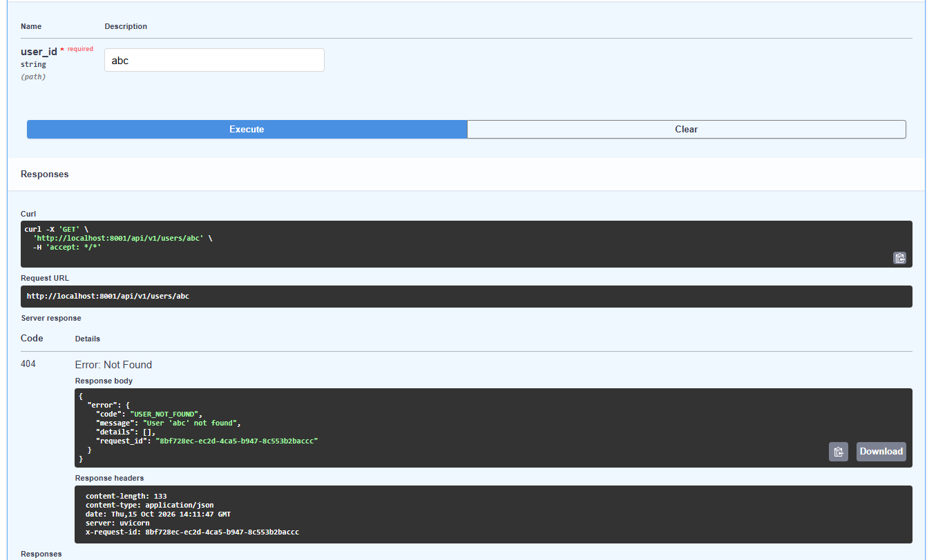
Figure 15. User Service Testing
Result
- 20 tests passed
- 0 failed

Payment Service
Screenshots
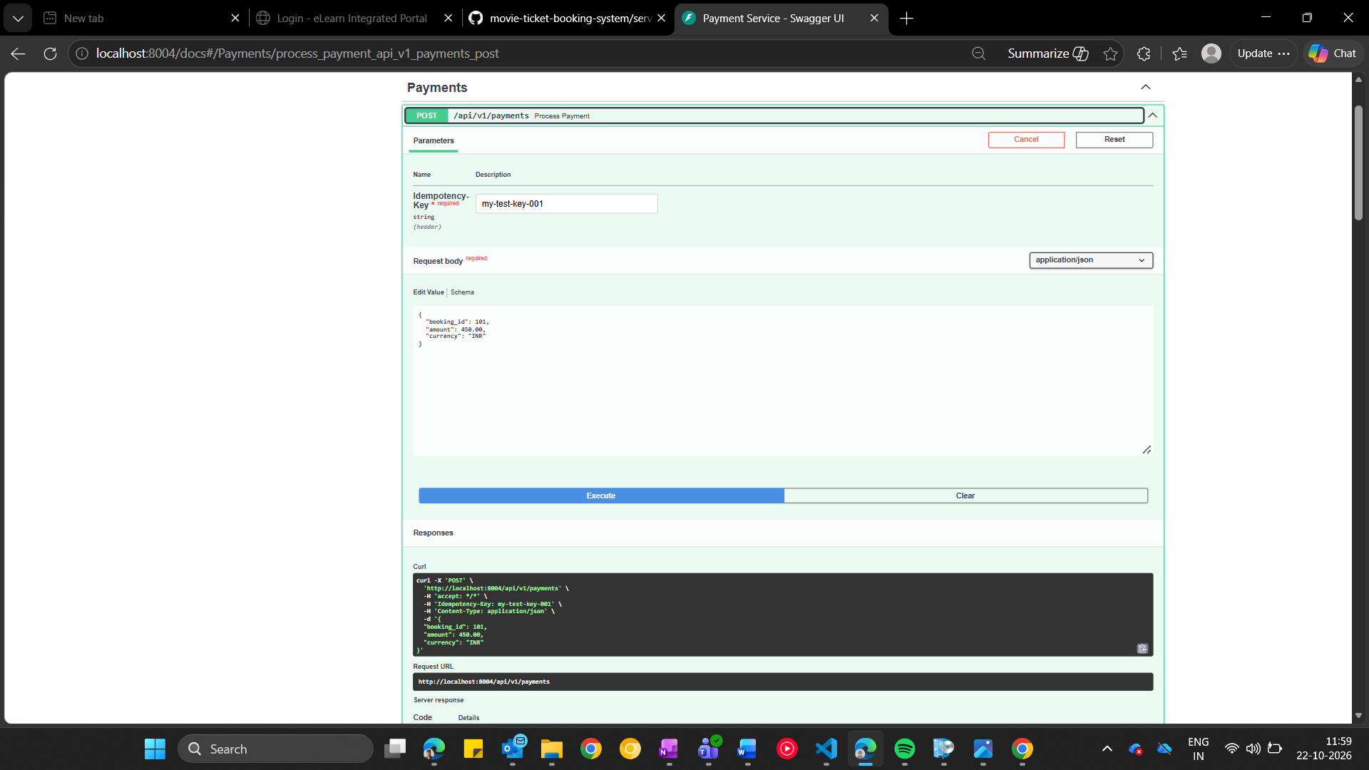
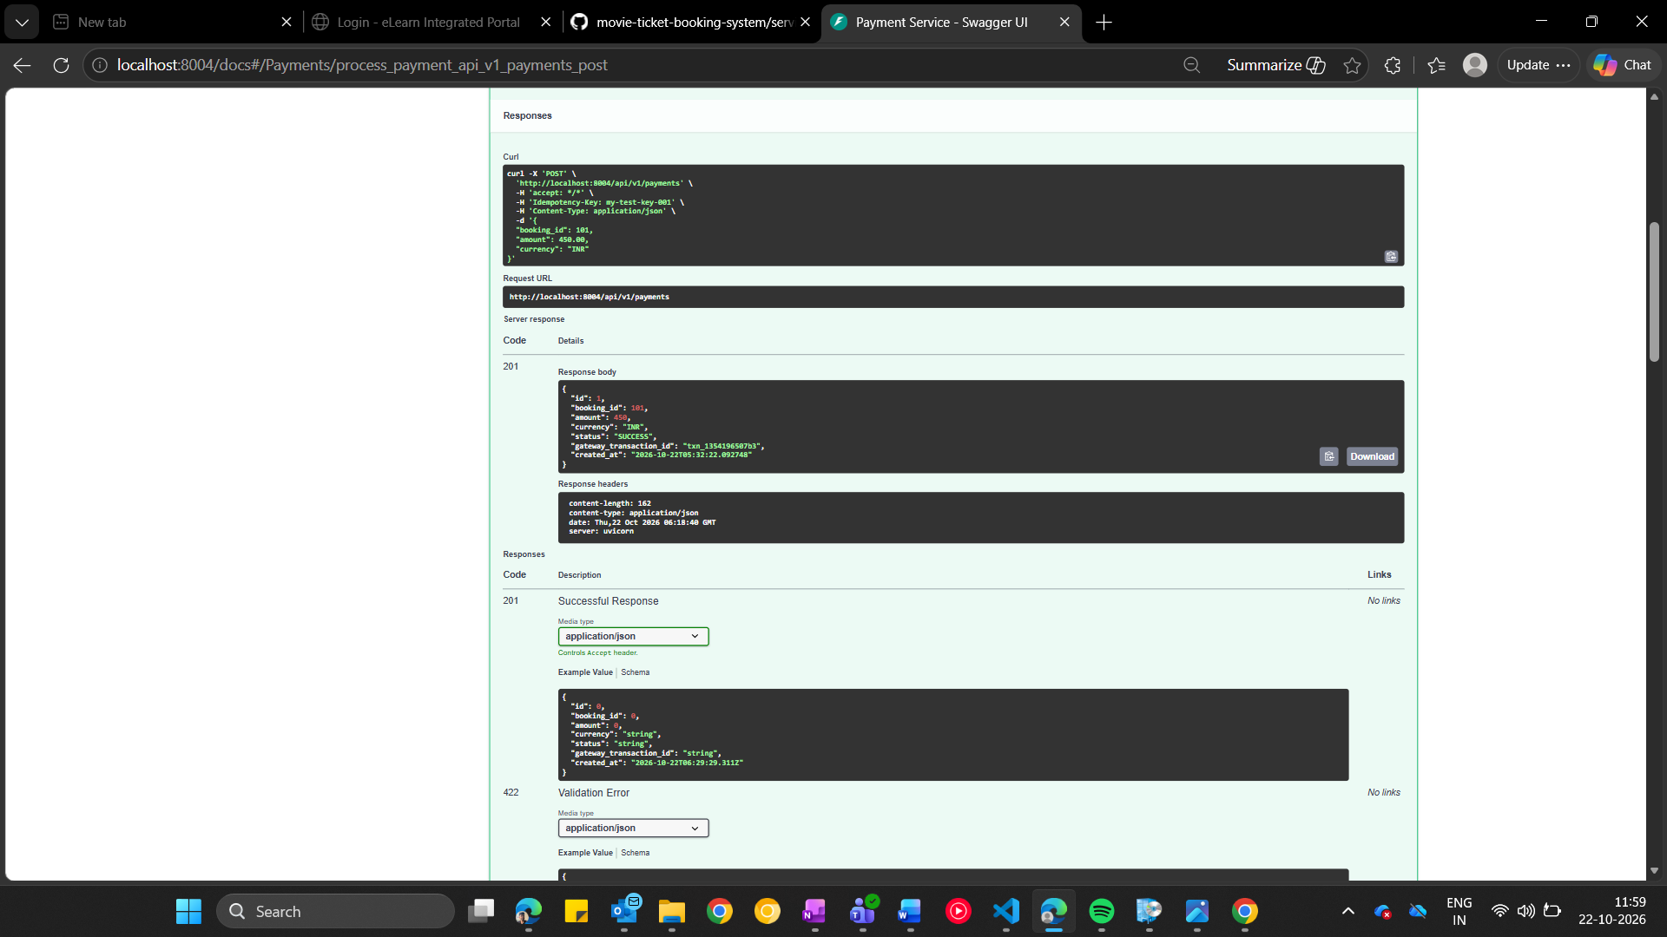
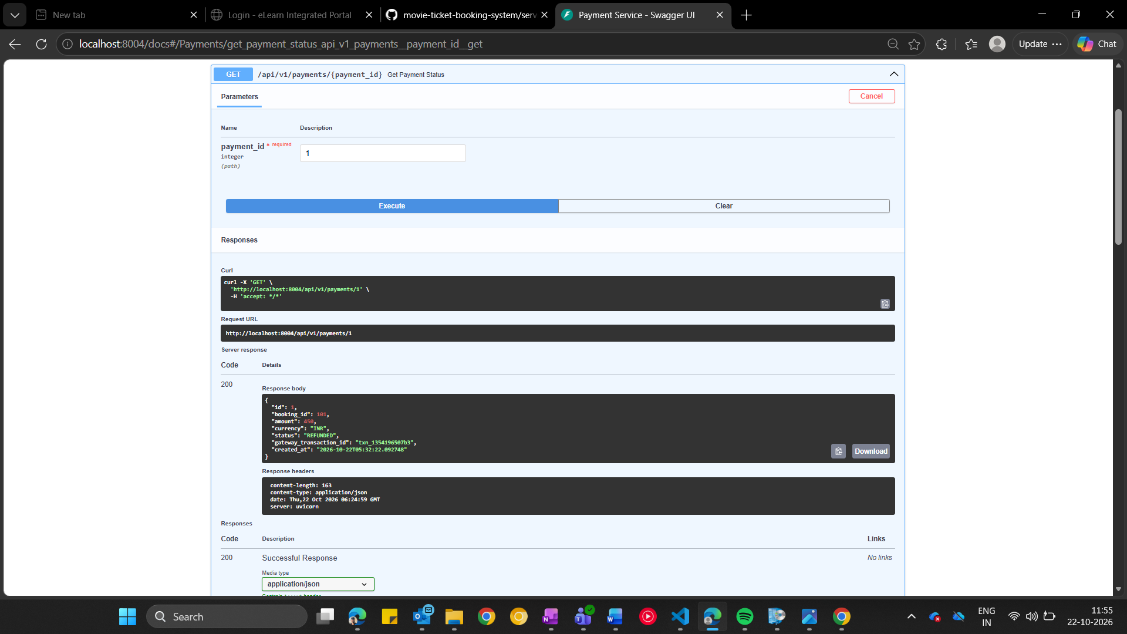
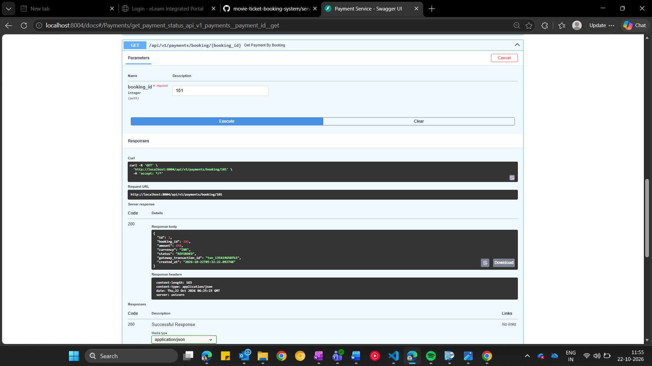
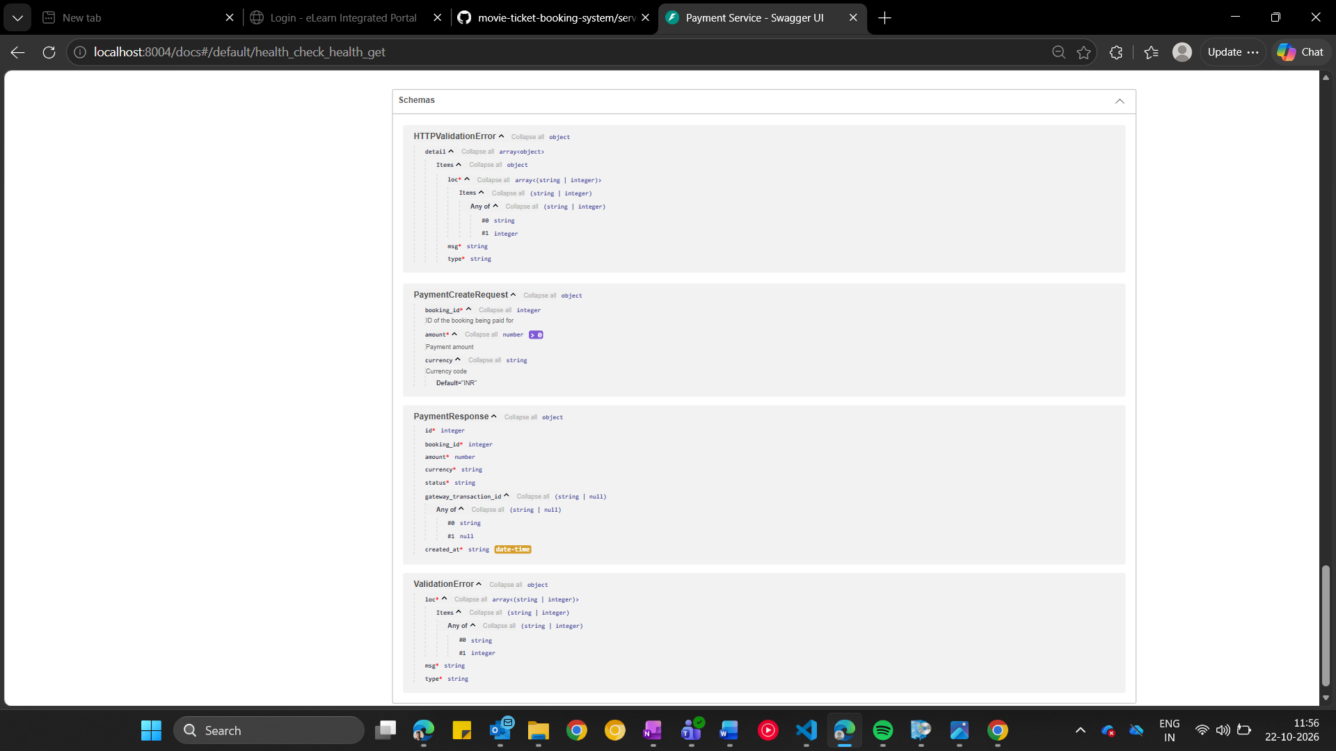
Figure 16. Payment Service Testing
Result
- 7 tests passed
- 0 failed

Notification Service
Screenshots
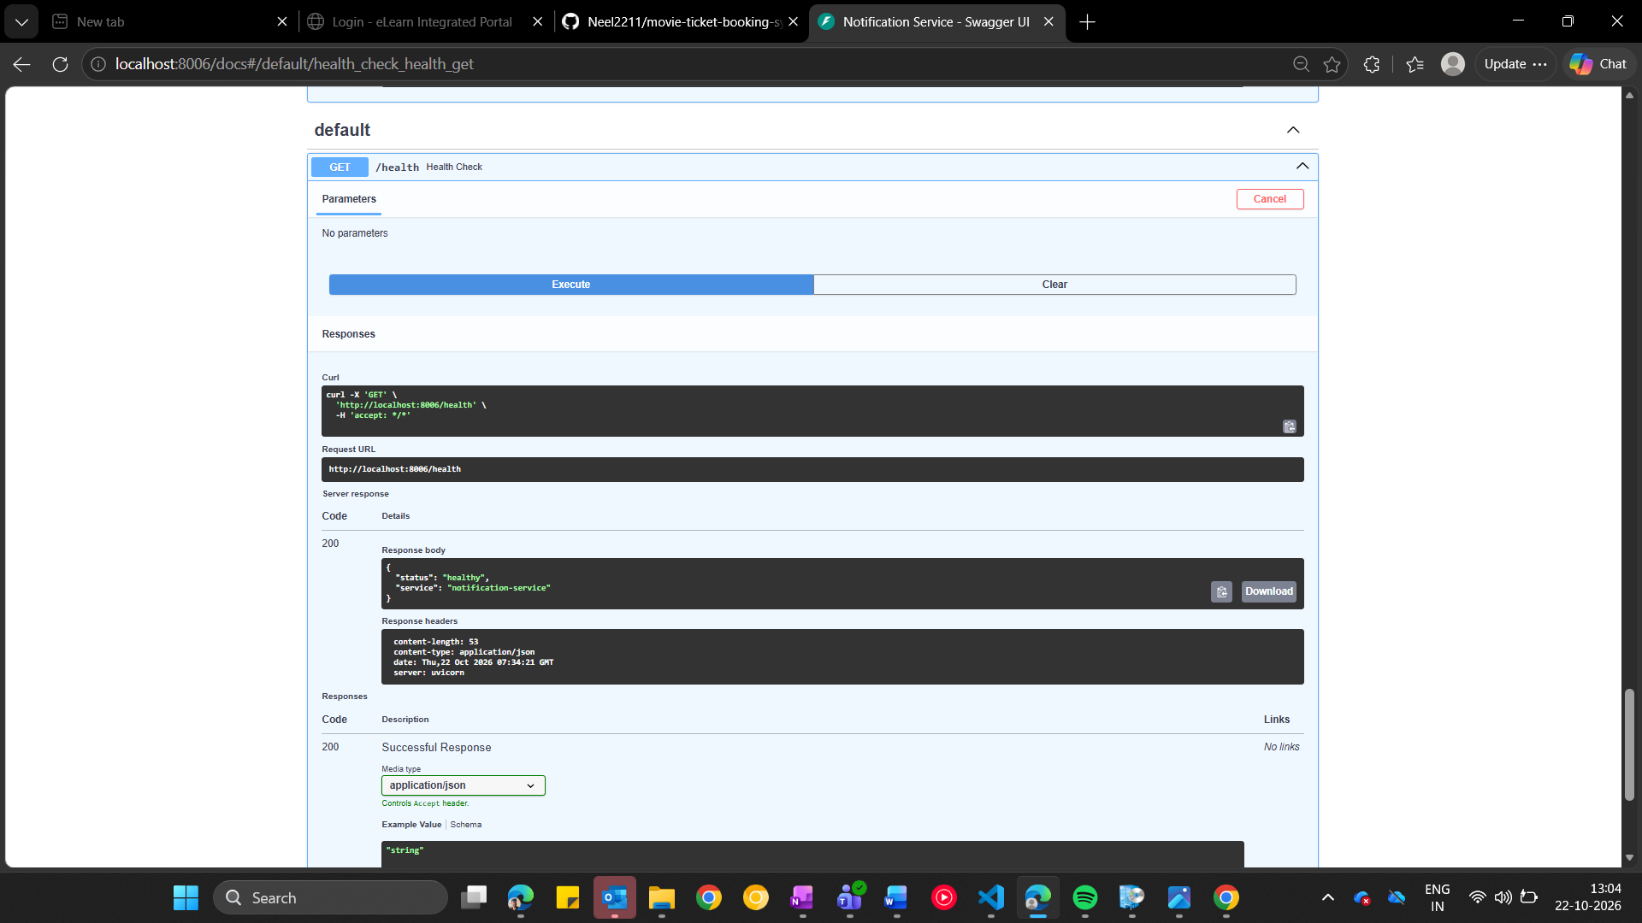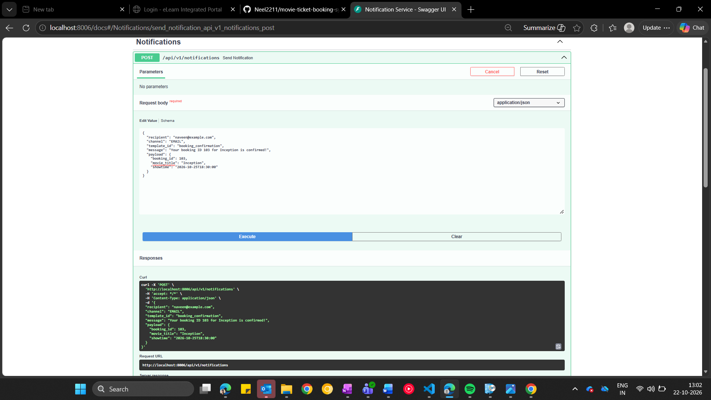
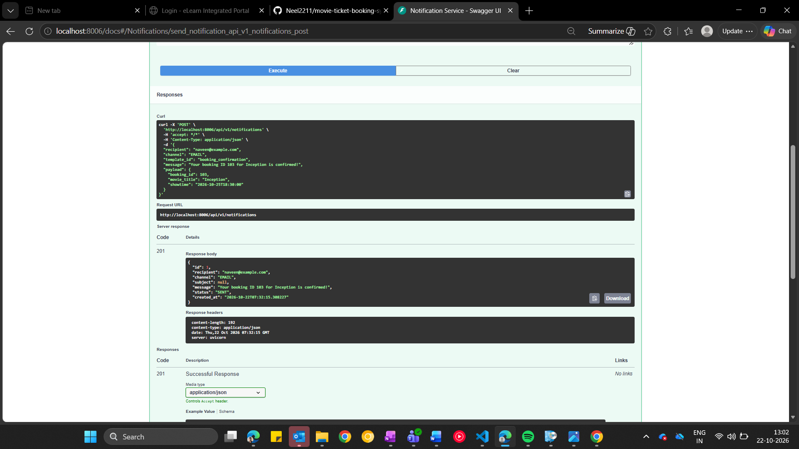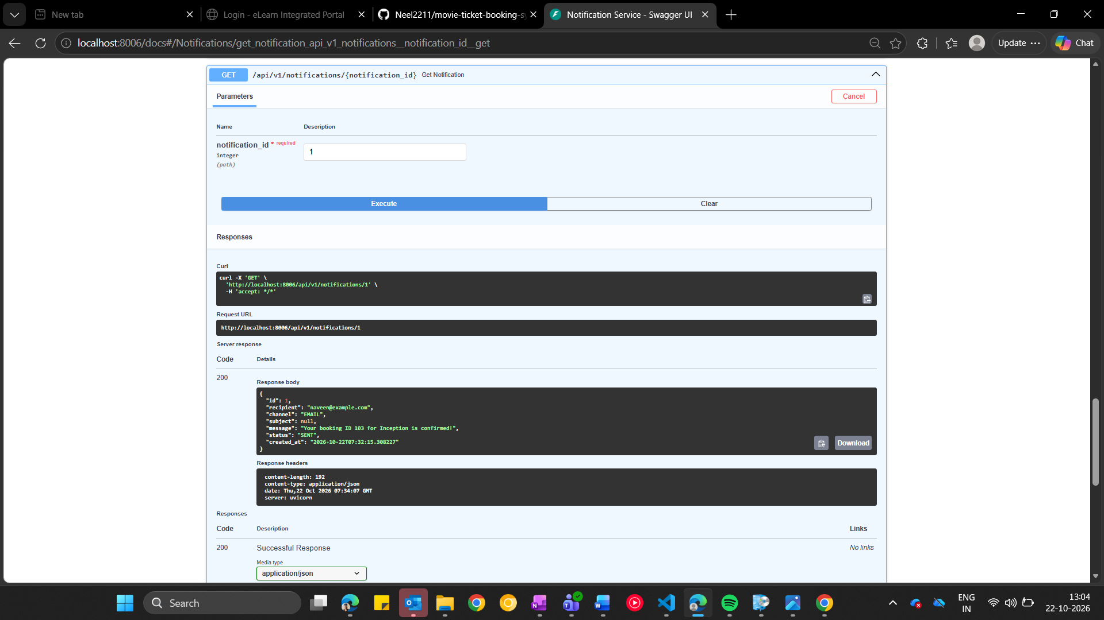
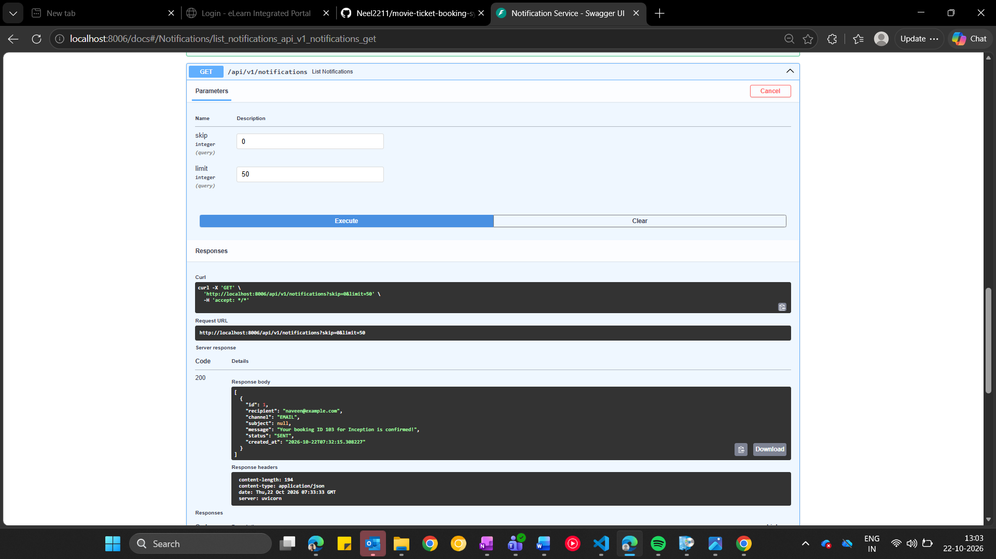
Figure 17. Notification Service Testing

End-to-End Integration Testing
Objective
Validate communication among all five services.
Services Running
- User Service 8001
- Show Service 8002
- Booking Service 8003
- Payment Service 8004
- Notification 8006
Integration Verification
Execution:
- python integration_demo.py
Validated:
- User creation
- Booking creation
- Seat reservation
- Double booking prevention
- Payment failure compensation
- Notification generation
- User business rules

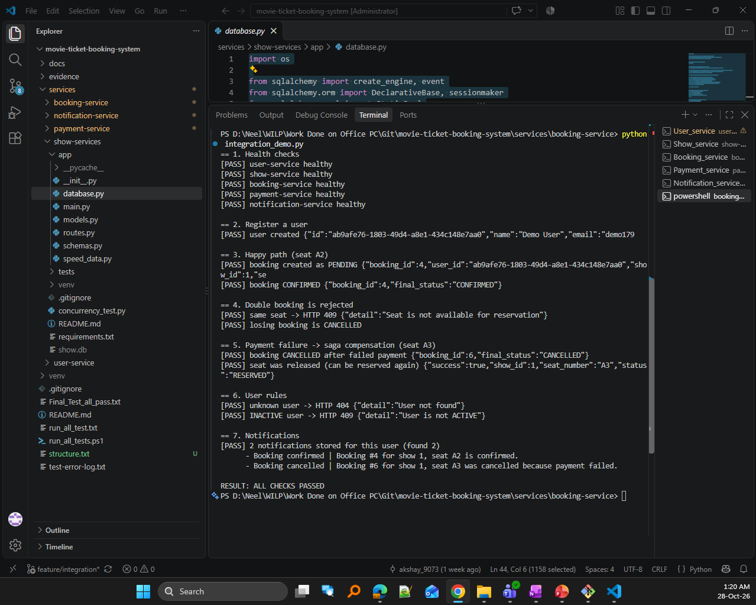
Figure 18. End-to-End Integration Validation
Outcome
- RESULT: ALL CHECKS PASSED

8. Design Decisions and Trade-Offs
Decision 1: Saga Orchestration vs Choreography
Selected:
Orchestration
Reason:
Simpler coordination and debugging.

Decision 2: SQLite vs MySQL
Selected:
SQLite
Reason:
Minimal setup complexity and sufficient for demonstration.

Decision 3: REST vs gRPC
Selected:
REST
Reason:
Built-in OpenAPI support and easier testing using Swagger/Postman.

9. Limitations and Future Work
Limitations
  - Notifications are mocked.
  - Payment gateway is simulated.
  - Authentication is not implemented.
  - SQLite limits concurrent scalability.
Future Work
  - JWT Authentication
  - Containerization using Docker
  - Kubernetes deployment
  - Asynchronous messaging using Kafka/RabbitMQ
  - Real payment gateway integration

10. Links to Deliverables
GitHub Repository
https://github.com/Neel2211/movie-ticket-booking-system
Demo Video
https://drive.google.com/file/d/1QGtG_73qK3UGgOQIvoZlCURTHOuAWsj2/view?usp=sharing
Supporting Documents
https://drive.google.com/drive/folders/1vKiZQ2M82bdlyzjHHlD6VDuAoxwchvmg?usp=sharing

11. Conclusion
The Movie Ticket Booking System was successfully implemented using a microservices architecture. The solution demonstrates database-per-service design, concurrency control, idempotent request processing, and Saga-based transaction management. Integration testing verified successful interaction among all five microservices, with all test scenarios passing successfully. The final implementation satisfies all assignment requirements and demonstrates the practical application of scalable service design principles.

Appendix A – Contribution Table
Member | Contribution
Gujar Neel Lukesh | Booking Service implementation, booking state machine, Saga orchestration, integration testing, report preparation
Yamuna P Hegade | User Service implementation, validation rules, lifecycle management, testing
Bhandari Akshay Sunil | Show Service implementation, seat reservation logic, concurrency control, Integration testing
Naveen Venkat P | Payment Service implementation, idempotency handling, compensation workflows
Shared | Notification Service, end-to-end testing, final integration

Appendix B – Individual Reflection
B.1 Gujar Neel Lukesh
I was responsible for the implementation of the Booking Service and acted as the integration coordinator for the project. My primary tasks included developing booking APIs, implementing booking lifecycle management, designing the booking state machine, and coordinating service integration. I also implemented the Saga orchestration workflow to ensure consistency across distributed services when payment failures occurred.
The most challenging aspect of the project was handling distributed transactions while maintaining consistency between services. Implementing the Saga compensation workflow required careful consideration of state transitions and failure scenarios. I designed the workflow so that failed payments automatically trigger seat release and booking cancellation. Through this work I gained practical experience in microservice integration, service orchestration, and fault handling. If the project were extended, I would explore event-driven communication and asynchronous messaging to improve scalability and resilience.
This project improved my understanding of microservices architecture and distributed systems design.

B.2 Yamuna P Hegade
I was responsible for the User Service. My contribution included implementing user creation, retrieval, activation, deactivation, validation logic, and lifecycle management. I designed and enforced business rules to ensure that only valid and active users could participate in the booking process.
The most challenging part of my work was implementing business-rule validation and handling different user states consistently. I focused on ensuring that inactive users could not perform restricted actions and that duplicate user records were prevented. This project improved my understanding of API design, service ownership, validation strategies, and reliable error handling. In a future version of the application, I would enhance the User Service by introducing authentication, authorization, and role-based access control.
This project improved my understanding of microservices architecture and distributed systems design.

B.3 Bhandari Akshay Sunil
I was responsible for the Show Service. My work involved implementing show management, seat inventory management, seat reservation, seat release functionality, and concurrency handling. The service was designed to ensure that multiple users could not reserve the same seat simultaneously.
The most difficult aspect of this service was implementing concurrency control in a simple yet reliable manner. I designed seat reservation logic using atomic database operations so that only one request could successfully reserve a seat while competing requests were rejected. Through this implementation I learned how shared resources must be protected in distributed systems. Given more time, I would enhance the service with dynamic seat layouts, multiple screens, and richer show-management functionality.
This project improved my understanding of microservices architecture and distributed systems design.

B.4 Naveen Venkat P
I was responsible for the Payment Service. My contribution included payment processing APIs, idempotency handling, payment retrieval operations, and support for Saga compensation workflows. I implemented logic to ensure that repeated payment requests with the same idempotency key were processed only once.
The most challenging aspect of my work was implementing idempotent payment processing and ensuring that duplicate requests did not result in duplicate payment records. I also contributed to compensation handling by supporting the refund and failure scenarios required by the Saga workflow. This work improved my understanding of transaction consistency, payment reliability, and distributed-system error handling. If the system were extended further, I would integrate a real payment gateway and add more advanced fraud-prevention mechanisms.
This project improved my understanding of microservices architecture and distributed systems design.

Appendix C – AI Use Declaration
This project made use of AI-assisted tools, including Microsoft Copilot, to support activities such as report structuring, documentation drafting, architecture discussions, code review assistance, and technical writing improvement.
All implementation, debugging, testing, integration verification, challenge execution, evidence collection, and final validation activities were performed and reviewed by the project team members. AI-generated suggestions were evaluated, modified where necessary, and validated through actual implementation and testing before inclusion in the final submission.

